y = 2x + 6



|  |  |
| --- | --- |
| x | y |
| 0 | 6 |
| 1 | 8 |
| 2 | 10 |
| 3 | 12 |

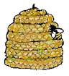

Table B

Table A

|  |  |
| --- | --- |
| x | y |
| 0 | 0 |
| 1 | 5 |
| 2 | 10 |
| 3 | 15 |
| 4 | 20 |



y = 5x



y = 2x



Table D

|  |  |
| --- | --- |
| x | y |
| 0 | 0 |
| 1 | 2 |
| 2 | 4 |
| 3 | 6 |



Table C

y = 2 + 3x



|  |  |
| --- | --- |
| x | y |
| 0 | 2 |
| 1 | 5 |
| 2 | 8 |
| 3 | 11 |



y = 3 + 2x



|  |  |
| --- | --- |
| x | y |
| 0 | 3 |
| 1 | 5 |
| 2 | 7 |
| 3 | 9 |
| 4 | 11 |



Table E

|  |  |
| --- | --- |
| x | y |
| 0 | 5 |
| 2 | 15 |
| 3 | 25 |
| 4 | 35 |



y = 5 + 10x



Table F

|  |  |
| --- | --- |
| x | y |
| 0 | -2 |
| 1 | 1 |
| 2 | 4 |
| 3 | 7 |
| 4 | 10 |



y = 3x + -2



Table G

y = 0.5x + 1



|  |  |
| --- | --- |
| x | y |
| 0 | 1.0 |
| 2 | 1.5 |
| 3 | 2.0 |
| 4 | 2.5 |



Table H

|  |  |
| --- | --- |
| x | y |
| 0 | 2 |
| 1 | 7 |
| 2 | 12 |
| 3 | 17 |
| 4 | 22 |



y = 5x + 2



|  |  |
| --- | --- |
| x | y |
| 0 | -2 |
| 2 | 8 |
| 3 | 18 |
| 4 | 28 |



y = 10x - 2



Table J

Table K

*c* = 3*m* + 2



Story 1

Story 1

A taxi cab driver charges $2 for a base fee and then $3 for each mile.

How much will it cost, c, for a ride of *m* mile?



A t-shirt company charges $10 for all orders and then $5 per shirt.

How much will it cost, c, for an order of *n* t-shirts?



c = 10 + 5n



Story 2

*c* = 0.25*n* + 0.50



A calling card charges $0.50 to connect a call. Additionally, it charges $0.25 a minute.

How much will it cost, *c*, for a phone call of *n* number of minutes?



Story 3

c = 10 + 0.50n



eMusic.com sells MP3s but you must sign up for $10 and each song is $0.50.

How much will it cost *c* for n number of songs?



Story 4

A calling card charges $0.75 to connect a call. Additionally, it charges $0.10 a minute.

How much will it cost, *c*, for a phone call of *n* number of minutes?



C = 50 + 25n



C = 0.10*n* + 0.75



Story 5

A flower shop charges $50 for decorating for a wedding and then $25 per table setting.

How much will it cost, *c*, for a wedding that will have *n* number of tables?



Story 6

Story 7

Story 7

Melissa has $50. She will earn $7 for each hour she works. How much money, *m*, will she have after working *n* hours?



*m* = 7*n* + 50



Story 8

m = 10n + 7



Edith has $7. She will earn $10 for each hour she works. How much money, *m*, will she have after working *n* hours?



y = 5x

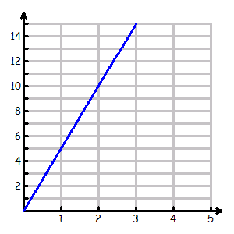

GRAPH 1

y = 6 + 2x

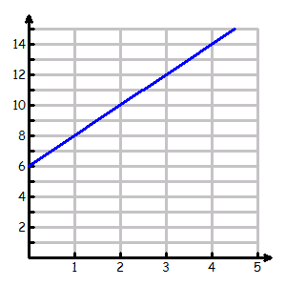

GRAPH 2

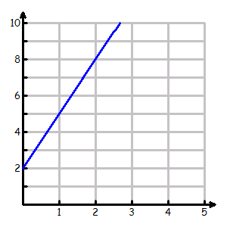

GRAPH 4

y = x + 1

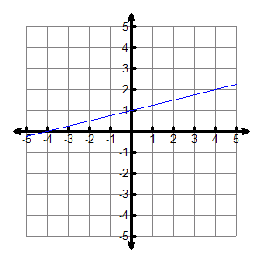

GRAPH 3

y = 2 + 3x



y = 9 + 5x

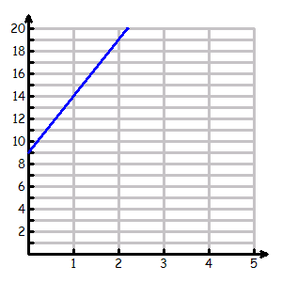

GRAPH 5

GRAPH 6

y = 5 + 10x

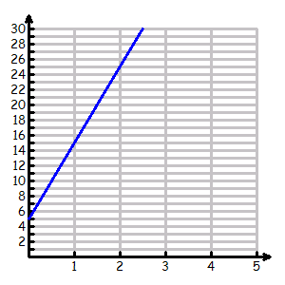

GRAPH 8

GRAPH 7

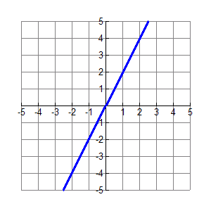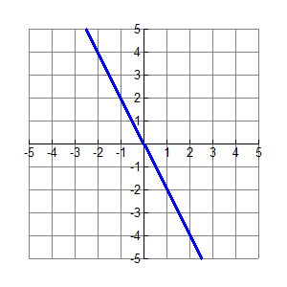

y = -2x + 0



y = 2x

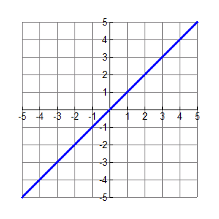

y = x



GRAPH 9

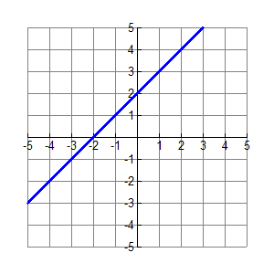

y = 1•x + 2



GRAPH 10

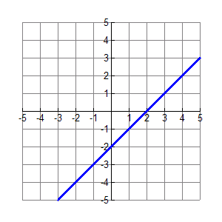

y = x - 2



GRAPH 11

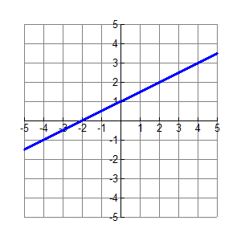

y = ½x + 1



GRAPH 12

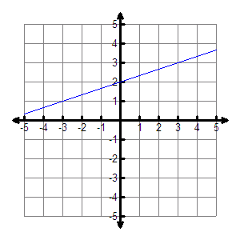

y = 



GRAPH 13

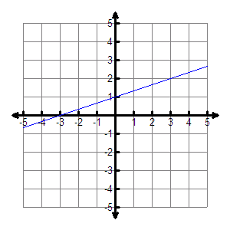

y = 



GRAPH 14

Name:___________________ Class Periods:_____



► Matching A Table to An Equation:

Write the equation that matches to each table.

Table A 🡪__________________________

Table B 🡪__________________________

Table C 🡪__________________________

Table D 🡪__________________________

Table E 🡪__________________________

Table F 🡪__________________________

Table G 🡪__________________________

Table H 🡪__________________________

Table J 🡪__________________________

Table K 🡪__________________________

► Matching A Story to An Equation:

Write the equation that matches to each story.

Story 1 🡪 __________________________

Story 2 🡪__________________________

Story 3 🡪__________________________

Story 4 🡪__________________________

Story 5 🡪__________________________

Story 6 🡪__________________________

Story 7 🡪__________________________

Story 8 🡪__________________________

.

► Matching A Graph to An Equation:

Write the equation that matches to each graph.

Graph 1 🡪__________________________

Graph 2 🡪__________________________

Graph 3 🡪__________________________

Graph 4 🡪__________________________

Graph 5 🡪__________________________

Graph 6 🡪__________________________

Graph 7 🡪__________________________

Graph 8 🡪__________________________

Graph 9 🡪__________________________

Graph 10 🡪__________________________

Graph 11 🡪__________________________

Graph 12 🡪__________________________

Graph 13 🡪__________________________

Graph 14 🡪__________________________